

Group#1

Okaz Library
Software Design Specification (SDS)
Version: 1.0
CM Identifier: G1_SE_SDS_Itr1_v1.0

Revision History

Sl. No. | Prepared/  Modified by | E-mail | Version | Date | Approved by | Descriptions/  Remarks
1. | Mohamed Mayla | mohamed.mayla @gmail.com | V1.0 | April 15,2013 | N/A | Design Models
2. | Eslam Hashem | eslam.hashem7 @gmail.com | V1.0 | April 16,2013 | Mohamed Mayla | Data Models and System Deployment
3. | Nada Karam | nada_karam23 @yahoo.com | V1.0 | April 16,2013 | Mohamed Mayla | Introduction
4. | Hagar Bedr | hagar.bedr @yahoo.com | V1.0 | April 17,2013 | Mohamed Mayla | System Architecture and Traceability to Requirements

Distribution list
Name | E-mail | Notes
Dr. Sayed Hemayed | hemayed@ieee.org | For approval
Eng. Omar Khaled | eng.oks@gmail.com | For approval

Table of Contents

1. Introduction 6
1.1 Purpose of this Document 6
1.2 Scope 6
1.3 Table of Acronyms and Definitions 7
1.4 References 7
1.5 Overview of Document 7
2. System Architecture 8
3. Design Models 9
3.1 Class Diagrams 9
3.1.1 CD1 9
3.1.2 CD2 10
3.2 Interaction Diagrams 11
3.2.1 SD1 11
4. Data Models 12
5. System Deployment 13
6. Traceability to Requirements 13

List of Tables

Acronyms and Definitions 7
Traceability to requirements 13

List of Figures
Figure 1 – System Architecture 8
Figure 2 – CD1 9
Figure 3 – CD2 10
Figure 4– SD1 11
Figure 5– database model 12
Figure 6– system deployment 13

Introduction
This SDS is for Okaz Library, which is a website for Okaz activity on Cairo University to let them easily manage the book shared with peoples (students)^{[4]}.

Purpose of this Document
The purpose of this SDS is to give all the information needed about the design of Okaz library website such as the class diagrams, the sequence diagrams and the description for each, as the basic idea of the project is to manage sharing books between students and make it easy to be managed with Okaz library managers (activity).
The website provide users (students) who want to loan a book to the library, easily upload the book cover (to make sure he has the book) with his name and phone number, after that he/her should deliver the book to the library managers, after that the book will appear on the website that is available to borrow.
The users (students) who want to borrow a book, should send request to borrow selected book from the website with his/her name and phone number, and then go the receive the book from the library for a certain time.
The manager of the Okaz library will manage all the above activities^{[4]}.

Scope
The scope of this SDS was discussed thoroughly by the team members developing this website with Okaz library activity managers. It’s was agreed upon that in the version 1.0 will have the full functionality of the website.
The system will provide the “smart confirmation code” feature that let managing all the activity by the managers more easy and fast, and the system will save the data on an online server.
The website will be ready to be published on the internet and ready to be used by the users.
The application will support simple use cases such as upload cover book, borrow a book and request confirmation by the managers with some complex use cases such as the generation of the “smart confirmation code” , the admin activity like delete a book^{[4]}.

Table of Acronyms and Definitions

Term | Definition
ASP.net | server-side Web application framework
HTML | Hyper Text Markup Language
HTTP | Hypertext Transfer Protocol
HTTPs | Hypertext Transfer Protocol Secure
IP | Internet Protocol
SDS | Software Design Specifications
SRS | Software Requirements Specifications

table 1 – Acronyms and definitions

References
- Software Engineering Course Lecture Notes, Dr. El Sayed Hemayed.
- www.asp.net
- http://www.w3schools.com
- The Software Requirements Specifications document (SRS).
- http://code.google.com/p/software-engineering-project-cufe-2015-group1
- www.facebook.com
- http://www.agilemodeling.com/artifacts

Overview of Document
The rest of this document is going to specify the system architecture and the subsystems of the project in a way that will be very easy to understand, it will also describe the different subsystems of the project and the classes of each subsystem, also it will thoroughly describe the sequence diagram of every use case of the project, along with the ERD and the Relational modeling of the database.

System Architecture
The system of this project is going to be decomposed into three subsystems, or layers;
- The User Application Layer.
- The Web Service Layer.
- The Database Layer.
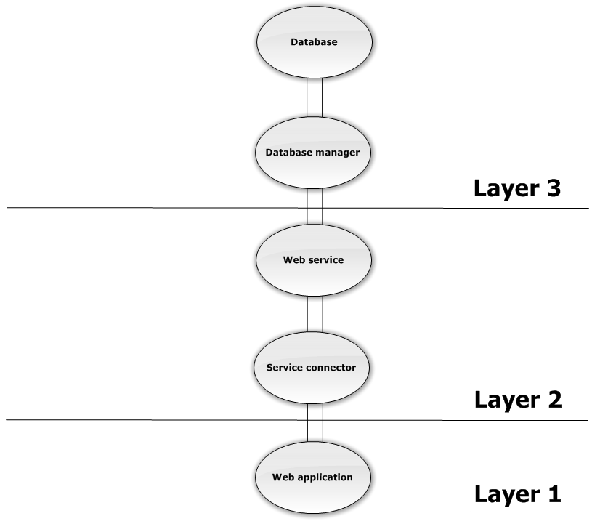
Each layer has its own classes and methods of interacting with other layers, so the structural model we are going to use here is the layered model; the following figure shows the system architecture and its layers.

Figure 1 – System Architecture

Design Models

Class Diagrams

CD1
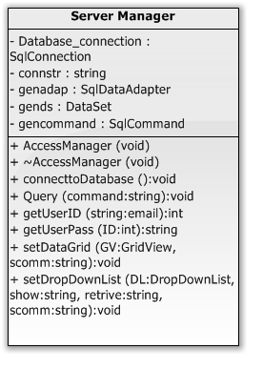
Figure 2 – CD1

CD2
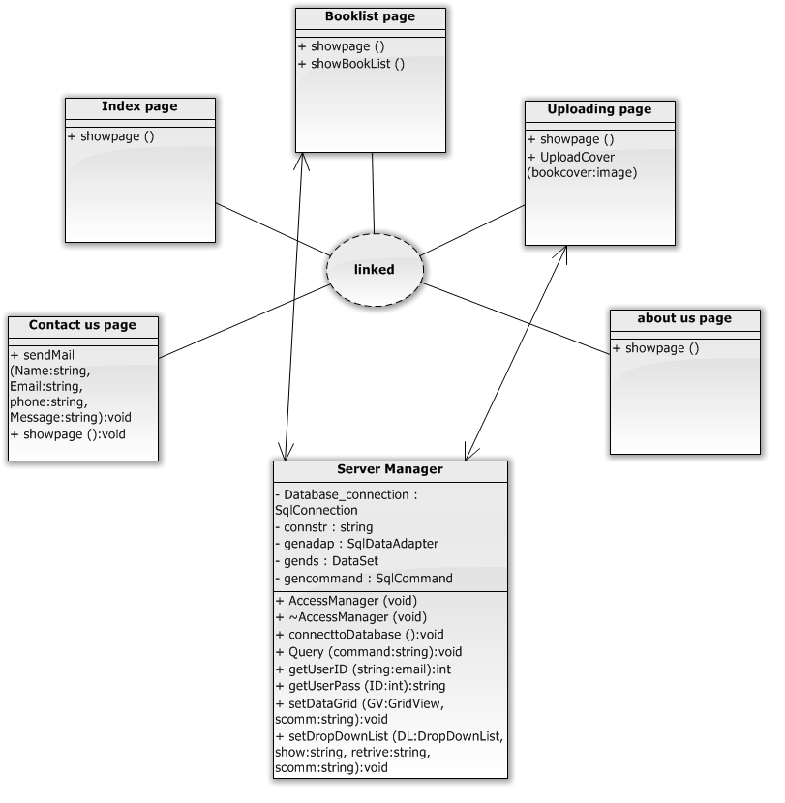

Figure 3 – CD2

Interaction Diagrams

SD1
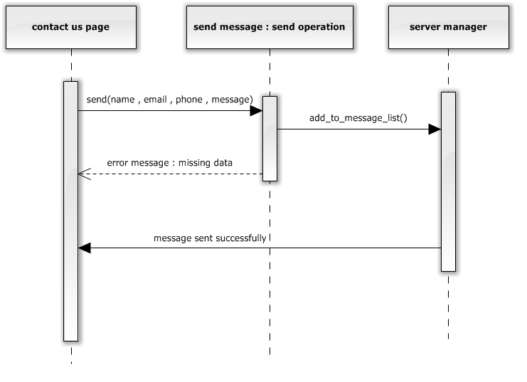
Figure 4– SD1

Data Models
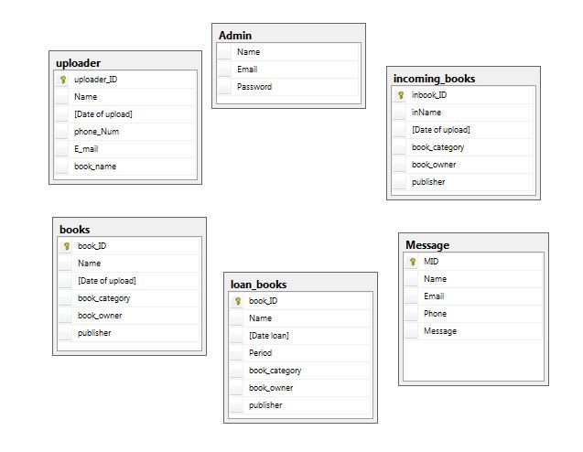
Figure 5– database model

System Deployment

“Device”
Application server

“Device”
Database server

“Device”
Personal computer

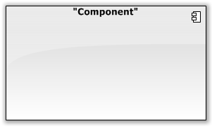

Web browser

Okaz library web application
Okaz library database server

Figure 6– system deployment

Traceability to Requirements

 | CD_1 | CD_2 | SD_1
US01 |  | 
US02 |  | 
US03 | 
US04 | 
US05 | 
US06 |  |  | 
US07 | 
US08 | 
Table 2 – traceability to requirements

